Management of Encephalocele in Infants: A 5-Years Retrospective Study in Benha, Egypt
Mohamed M Elmaghrabi*⁽¹⁾, Ahmed A Arab ⁽¹⁾, Mona A Elawady ⁽²⁾, Mohammed Mourad ⁽¹⁾

¹Neurosurgery, ²Public Health Departments, Faculty of Medicine, Benha University, Benha, Egypt
Abstract
Purpose: To overview the management of encephalocele and evaluate the outcome in our institutions through a period of 5 years.
Methods: This is a retrospective study was performed on all infants that were admitted and operated upon for encephalocele in department of Neurosurgery of Benha University and Benha specialized children hospitals in the last 5 years, from June 2016 to June 2021.
Results: This study had 58 infants with encephalocele were with age ranged from 1 to 345 days with a mean age ±SD of 244 ±20 days. 6 types of encephalocele according to location and shape were treated; 22 (37.9%) occipital, 12 (20.7%) atretic, 9 (15.5%) vault, 7 (12.1%) occipito-cervical, 5 (8.6%) ethmoidal, and 3 (5.2%) double encephaloceles. we classified encephaloceles into 3 sizes; small, medium and large. We found that 20.7% of infants associated with hydrocephalus. Only 5 deaths were reported and 3 of them were not related to encephalocele and its management.
Conclusions: Management of encephalocele includes full investigations and proper diagnosis for optimum surgical plan. Meticulous patient preparation, surgery, and good postoperative care and follow up are mandatory for good outcome. Associated hydrocephalus which was not significantly related to encephalocele type or size and neurological & non-neurological conditions are common and should be taken in consideration.
Key words: Encephalocele, infants, hydrocephalus, retrospective.
Introduction:
Encephaloceles are congenital malformation characterized by herniation of the brain with or without the meninges through a skull defect due to failure of normal midline fusion of cranial neural tube ^{(1,2).} Approximately 70% to 90% of encephaloceles are located in the occipital region⁽³⁾. This congenital lesion is a worldwide common problem in the practice of pediatric neurosurgery ⁽⁴⁾.
Genetic and environmental factors are thought to play a role in the development of such congenital pathology ⁽⁵⁾. TORCH infections (toxoplasma, rubella, cytomegalovirus, herpes simplex virus) are documented in many patients ⁽⁶⁾. Trauma, tumors, or iatrogenic injury can be a leading cause for acquired encephaloceles with traumatic birth rupture leads it as an emergency situation ⁽⁷⁾.
The encephaloceles in occipital region mostly followed by fronto-ethmoidal and parietal regions should be repaired in the first few months of life as intracranial content of the sac can be identified easily and complete repair of dural and skull defect can be achieved. Computed Tomography (CT) 3-dimesion is preferred to visualize bony defects (either internal or external), and Magnetic Resonance Imaging (MRI) is helpful to differentiate herniated content and to detect other anomalies ⁽⁷⁾.
Purpose: To overview the management of encephalocele and evaluate the outcome in our institutions through a period of 5 years.

Patients and Methods:
Type of the study: this is a retrospective study in last five years period.
Study design: This study was performed on infants (first year of life) admitted and operated in departments of Neurosurgery at Benha University and Benha specialized children hospitals (BENCH) from June 2016 to June 2021. All medical records of infants who were admitted with encephalocele and evaluated regarding age, sex, site and size of encephalocele, associated neurological and systemic abnormalities were obtained. Investigations such as skull radiographs, three-dimensional CT, MRI brain were done.
Surgical details: Infants with posterior encephaloceles were placed in prone position or lateral position in cases with large encephalocele, vault encephaloceles were put in supine or lateral position and anterior skull base encephaloceles were put in supine position with 30 degrees flexion. Under general anesthesia with special care was taken to the endotracheal tube, close monitoring to electrolytes and vital signs as well as the patient’s body temperature to avoid hypothermia, We did an ellipse-shaped skin incision over sac followed by skin dissection then the sac was opened, cerebrospinal fluid (CSF) was slowly evacuated, the sac content was visualized and gently dissected and encountered, then repositioned inside through the dural opening. Dealing with the neural tissue depends on the preoperative MRI, nature of the herniated tissue visualized during surgery (gliotic or not) in most cases we excised gliotic neural tissue. Step by step hemostasis was important to avoid blood loss. The dural defect is exposed and closed with a re-absorbable suture, skull periosteum surrounding the skull defect could be dissected and used in its repair. The hole was closed with an absorbable gelatin sponge after the watertight closure of the dura then the wound was closed with closely approximated sutures to prevent postoperative CSF leakage. Finally, reconstruction of skin, good hemostasis, and closure in layers without drain were done. Ruptured encephaloceles were entered as emergency cases within 24 hours to guard from infection.
In anterior skull base encephalocele (Figure 1), normal herniated frontal brain with intact meninges through basal bony defect was usually seen, here a modified sutar incision was done followed by bilateral frontal bone craniotomy then open the dura and retraction of frontal lobes with gentle retraction of healthy herniated part of frontal lobe afterthat extradural dissection of sac from defect followed by cauterization and suturing of redundant dura then close the defect with part of frontal craniotomy bone flap and closure of opened dura, the bone flap was returned back followed by hemostasis and skin closure with external drain.
Postoperatively, the patients were shifted to a regular pediatric ward or incubator except for one case who needed postoperative intensive care due to other health problems unrelated to surgery. Additional procedures included ventriculo-peritoneal (VP) shunt (for hydrocephalus associated with encephalocele). 12 procedures were done, 4 patients had VP shunt before encephalocele surgery, and 8 patients need VP shunt after it.
Follow-up: All infants were assessed postoperatively with clinical examination and CT brain with a follow-up period ranging from 12-24 months.
Ethical approval: This research accepted by Research Ethics Committee (REC) of faculty of medicine, Benha University. The reference number of the ethics approval from the ethics committee: RC 20/6/2021. All procedures performed in studies involving human participants were in accordance with the ethical standards of the institutional and/or national research committee and with the 1964 Helsinki declaration and its later amendments or comparable ethical standards.
A written informed consent was taken from parents of infants after explaining all steps of this study.
Statistical analysis: The program used for statistical analysis was SPSS version 20. Quantitative data were analyzed using mean, standard deviation (SD), while frequency and percentage were used with qualitative data. Fischer exact test was used to compare frequencies. The corresponding distribution tables were consulted to get the “P” (probability value). Statistical significance was accepted at a P-value ≤0.05while a P-value > 0.05 was considered insignificant.

Result
Fifty-eight infants with encephalocele were treated surgically in this study, 32 males (55%) and 26 females (45%). Their age ranged from 1 to 345 days with a mean age of 244 ± 20 days.
6 types of encephalocele according to location and shape were treated in this study; we had 22 (37.9%) occipital, 12 (20.7%) atretic, 9 (15.5%) vault, 7 (12.1%) occipito-cervical, 5 (8.6%) ethmoidal, and 3 (5.2%) double encephaloceles (Figure 2).
At presentation and examination 10 (17.2%) infants had ruptured encephalocele; 5 occipital, 3 occipito-cervical, and 2 vault encephaloceles. We had 12 (20.7%) infants that were associated with hydrocephalus; 4 occipital, 3 occipito-cervical, 2 vault, 2 atretic, and one double encephalocele case.
During follow up we had 5 deaths (8.6%) ; 2 deaths in occipito-cervical type, and 1 in each of occipital, vault, and ethmoidal types with one case from hypoxia in early post-operative period one due to cerebritis of ruptured sac and three unrelated general causes in late period. There was no significant statistical relating incidence of rupture, association of hydrocephalus, or deaths to encephalocele types (Table 1).
Associated neurological and non-neurological conditions, Table 2, were found in patients with encephalocele in this study. We had 8 infants (13.8%) who had meningiomyelocele, 5 (8.6%) had cord syrinx, 3 (5.2%) had Chiari type 3, 24 (41.4%) had non-surgical brain anomalies (as agenesis corpus callosum, dandy walker cyst, brain atrophy, shizencephally and others) and 15 (25.9) had other congenital extra neural anomalies (fallot’s tetralogy, cardiac septal defect, syndactyly and others).
According to size, Table 3, we classified encephaloceles into 3 sizes; small with a volume 4 to 18 cm^{3,} medium with a volume > 18 to 72 cm³, and large of a volume > 72 to 520 cm³. We had 19 (32.8%) small, 29 (50%) medium and 10 (17.2%) large encephaloceles. Hydrocephalus was associated with 4 out 19 of small encephaloceles (21.1%), 6 out of 29 medium sized (20.7%), 2 out of 10 large sized (20%) which was statistically insignificant (Figure 3).

Discussion:
In our retrospective study, Fifty-eight infants with encephalocele were treated surgically 32 males (55%) and 26 females (45%). Many neural tube defects have sex predominance in females, but it is more evident in cases of encephalocele (4.5:1) ⁽⁸⁾. Female patients are more likely to have an occipital encephalocele (1.9:1) than an anterior encephalocele ⁽⁹⁾. Nath et al. ⁽¹⁰⁾ found that females were affected predominantly which correlate with previous reports. On the other hand in our experience, we found that males are predominance (55%) matching with Shilpakar et al. ⁽¹¹⁾ in their series.
In our study, age ranged from 1 to 345 days with a mean age of 244 ± 20 days. Lorber et al. ⁽¹²⁾ in their series documented that most common presenting age was 30 days with only one child presented at the age of 6 years. Rehman et al., documented in their series of 50 patients that the average age at presentation was 2.4 months ⁽⁹⁾. Ravindra et al., in their study including 19 patients documented that the age of presentation located between 1-day old infant and 6 years child ⁽¹³⁾.
Comparing our findings to Ravindra et al. ⁽¹³⁾ regarding location and shape of the lesion where we found; (37.9%) occipital, (20.7%) atretic, (15.5%) vault, (12.1%) occipito-cervical, (8.6%) ethmoidal, and (5.2%) double encephaloceles. And they found that Occipital encephaloceles accounted for (60%), occipito-cervical (20%), parietal (10%), and (5%) had a double encephalocele (one atretic and other was occipital). Examination at presentation in study reveals 3 patients with ruptured encephalocele while we detected ruptured encephalocele in 10 infants.
Associated neurological and non-neurological condition were seen in patients with encephalocele in our study, 13.8% who had meningiomyelocele, 8.6% had cord syrinx, 5.2% had Chiari type 3, 41.4% had non-surgical brain anomalies and 25.9 had other congenital extra neural anomalies. Encephaloceles have a high prevalence of associated intracranial anomalies. Associated anomalies depend on the location of the encephalocele as Achar et al. ⁽¹⁴⁾, documented association of some neurological conditions with occipital encephaloceles have higher probabilities of posterior fossa malformations such as arachnoid cyst, agyria-pachygyria complex, Dandy-Walker malformations, and callosal anomalies. Other associations: Chiari malformation, meningomyeloceles, and syrinx ⁽¹³⁾.
According to size, we classified encephaloceles into 3 sizes; small with a volume 4 to 18 cm³, medium with a volume > 18 to 72 cm³, and large of a volume > 72 to 520 cm³. Rehman et al. estimated that the size of the sac ranged from 2 cm × 3 cm to 27 cm × 15 cm ⁽⁹⁾.
Hydrocephalus was associated in 21.1% of small encephaloceles, 20.7% of medium sized and 20% of large sized which was statistically insignificant. We found that no relation between size of sac and hydrocephalus. Rehman et al. ⁽⁹⁾ found that (32%) of patients may present with increased head circumference and hydrocephalus. Bui et al. ⁽¹⁵⁾ in their study documented that hydrocephalus is common in 40% to 60% of occipital encephaloceles cases. Postoperative hydrocephalus should be managed through ventriculoperitoneal (VP) shunts as one or two-stage procedures ⁽¹⁶⁾. Rehman et al. ⁽⁹⁾ reported 4 (8%) developed hydrocephalus after repair of the sac which was treated with placement of ventriculoperitoneal shunt. One (2%) patient did not recover from anesthesia. Bui et al. ⁽¹⁷⁾ reported that occipital encephalocele is commonly associated with hydrocephalus compared to other types of encephalocele.
Hydrocephalus is important predictor of developmental delays in patients with encephalocele and develops after surgery in some cases ⁽¹⁸⁾. VP shunt should be placed before complete repair of encephalocele in these patients ⁽¹⁹⁾. In our study, VP shunt was done in 12 infants, 4 patients had shunt before encephalocele surgery, and 8 patients need shunt after surgery.
During follow up in our study we had 5 deaths (8.6%); one case from hypoxia in early post-operative period, one due to cerebritis of ruptured sac and three unrelated general causes in late period. Lorber et al. ⁽¹²⁾ documented 25 deaths (14.9%) in their series of 167 patients 14 deaths either before or during operation or very soon afterwards and 11 late deaths. 28 of the survivors had hydrocephalus and concluding that the presence or absence of brain matter in the herniated sac is the single most important prognostic factor. Large encephalocele is associated with high incidence of CSF leakage due to large defect which in turn may predispose infection ⁽²⁰⁾.
Kiymaz et al. ⁽²¹⁾ mentioned that many factors can affect the prognosis of the disease such as 1)location: Location of the sac with its content which is mainly vermis and rarely cerebellum to a varying extent; however, occasionally occipital lobes do herniate, 2) Size of sac and amount of brain tissue, 3) hydrocephalus, 4) associated malformation and 5) associated infections. Early surgery is recommended for encephalocele to prevent rupture of the sac, reduce CSF leak, and meningitis with special emphasis during surgery to avoid hypothermia, minimizing the blood loss, and monitoring of electrolytes ⁽²²⁾.

Conclusion:
Management of encephalocele includes full investigations and proper diagnosis for optimum surgical plan. Meticulous patient preparation, surgery, and good postoperative care and follow up are mandatory for good outcome. Associated hydrocephalus which was not significantly related to encephalocele type or size and neurological & non-neurological conditions are common and should be taken in consideration

Conflict of interest: No conflict of interest.
Acknowledgment: The authors thank the patients and their first order relatives of all included cases.
Funding: The authors declare that no funds, grants, or other support were received during the preparation of this manuscript.

References:
1. Agthong S, Wiwanitkit V. Encephalomeningocele cases over 10 years in Thailand: A case series. BMC Neurol. 2002; 2:3.
2. Lo BW, Kulkarni AV, Rutka JT, Jea A, Drake JM, Lamberti-Pasculli M, et al. Clinical predictors of developmental outcome in patients with cephaloceles. J Neurosurg Pediatr. 2008; 2:254–7.
3. Arora P, Mody S, Kalra VK, Altaany D, Bajaj M. Occipital meningoencephalocele in a preterm neonate. BMJ Case Rep. 2012.
4. Mahapatra AK, Agrawal D. Anterior encephaloceles: A series of 103 cases over 32 years. J Clin Neurosci. 2006; 13:536–9.
5. Tirumandas M, Sharma A, Gbenimacho I, Shoja MM, Tubbs RS, Oakes WJ, Loukas M. Nasal encephaloceles: a review of etiology, pathophysiology, clinical presentations, diagnosis, treatment, and complications. Childs Nerv Syst. 2013; 29(5):739-44.
6. Yucetas SC, Uçler N. A Retrospective Analysis of Neonatal Encephalocele Predisposing Factors and Outcomes. Pediatr Neurosurg. 2017; 52(2):73-76.
7. Gump WC. Endoscopic Endonasal Repair of Congenital Defects of the Anterior Skull Base: Developmental Considerations and Surgical Outcomes. J Neurol Surg B Skull Base. 2015; 76(4):291-5.
8. Berry AD, Patterson JW. Meningoceles, meningomyeloceles, and encephaloceles: a neuro-dermatopathologic study of 132 cases. J Cutan Pathol. 1991; 18(3):164-77.
9. Rehman L, Farooq G, Bukhari I. Neurosurgical Interventions for Occipital Encephalocele. Asian J Neurosurg. 2018; 13(2):233-237.
10. Nath HD, Mahapatra AK, Gunawat P. Case report: A torcular encephalocele with proatlas defect and os-terminale. Asian J Neurosurg. 2012; 7:84–6.
11. Shilpakar SK, Sharma MR. Surgical management of encephaloceles. J Neurosci. 2004; 1:45–8.
12. Lorber J, Schofield JK. The prognosis of occipital encephalocele. Dev Med Child Neurol. 1967; 13:75–86.
13. Ravindra Ramdurg, M. Sukanya, and Jayabrata Maitra Pediatric encephaloceles: A series of 20 cases over a period of 3 years J Pediatr Neurosci. 2015; 10(4): 317–320.
14. Achar SV, Dutta HK. Sincipital Encephaloceles: A Study of Associated Brain Malformations. J Clin Imaging Sci. 2016; 6:20.
15. Bui CJ, Tubbs RS, Shannon CN, Acakpo-Satchivi L, Wellons JC, Blount JP, Oakes WJ. Institutional experience with cranial vault encephaloceles. J Neurosurg. 2007; 107:22-5.
16. Gamache FW., Jr Treatment of hydrocephalus in patients with meningomyelocele or encephalocele: A recent series. Childs Nerv Syst. 1995; 11:487–8.
17. Bui CJ, Tubbs RS, Shannon CN, Acakpo-Satchivi L, Wellons JC, Blount JP, et al. Institutional experience with cranial vault encephalocele. J Neurosurg Pediatr. 2008; 1:22–5.
18. Tirumandas M, Sharma A, Gbenimacho I, Shoja MM, Tubbs RS, Oakes WJ, Loukas M. Nasal encephaloceles: a review of etiology, pathophysiology, clinical presentations, diagnosis, treatment, and complications. Childs Nerv Syst. 2013; 29(5):739-44.
19. Mardzuki AI, Abdullah J, Ghazaime G, Ariff AR, Ghazali M. Two-stage management of mega occipito-encephalocele. Med J Malaysia. 2003; 58:115–9.
20. Aslan A, Eser O, Dogru O, Aktepe F, Yurumez Y, Fidan H. Occipital mega encephalocele associated with acute inflammation. Pediatr Neurosurg. 2007; 43:65–6.
21.Kiymaz N, Yilmaz N, Demir I, Keskin S Prognostic factors in patients with occipital encephalocele. Pediatr Neurosurg. 2010; 46(1):6–11.
22. Verma SK, Satyarthee GD, Singh PK, Sharma BS. Torcular occipital encephalocele in infant: Report of two cases and review of literature. J Pediatr Neurosci. 2013; 8:207–9.
Tables
Table 1: comparison between rupture, hydrocephalus and death according to types of encephalocele
Type (No.) | Rupture (%) | Hydrocephalus (%) | Death (%)
Atretic (12) | 0(0.0) | 2(16.7) | 0(0.0)
Vault (9) | 2(20.0) | 2(16.7) | 1(20.0)
Occipital (22) | 5(50.0) | 4(33.3) | 1(20.0)
Occipto-cervical (7) | 3(30.0) | 3(25.0) | 2(40.0)
Double (3) | 0(0.0) | 1(8.3) | 0(0.0)
Ethmoidal (5) | 0(0.0) | 0(0) | 1(20.0)
Total (58) | 10(100) | 12(100) | 5(100)
Statistical test | FET= 2.33
P value | 0.99

Table 2: distribution of the studied group according to associated conditions
Associated conditions | No. (%)
Chiari type 3 | 3(5.2)
Meningiomyelocele | 8(13.8)
Syrinx | 5(8.6)
Brain nonsurgical anomalies | 24(41.4)
Other congenital (extra neural) anomalies | 15(25.9)
Total | 58 (100)

Table 3: comparison between different size of encephalocele and occurrence of hydrocephalus
Size (Cm³) | No | Hydrocephalus (%) | Test | P value
Small (4-18) | 19 | 4(21.1) | FET= 0.23 | 0.89
Medium (>18-72) | 29 | 6(20.7)
Large (>72-520) | 10 | 2(20.0)
Total | 58 | 12(20.7)

Figures:
Figure 1: An infant of ethmoidal (nasal) encephalocele; A) CT brain coronal view shows herniation of part frontal lobe with its meninges, B&C) intraoperative images shows that basal ethmoidal effect (B) and bony flap defect closure (C)

A 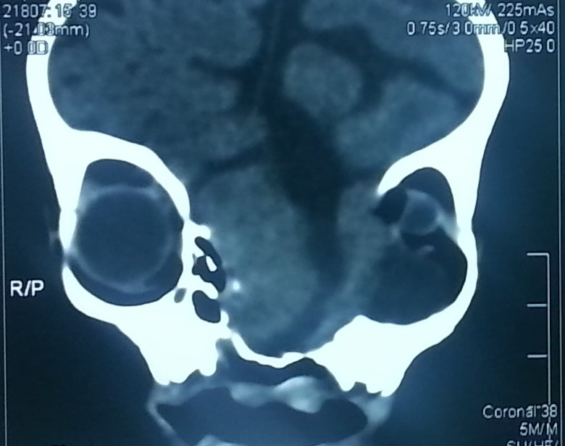 B 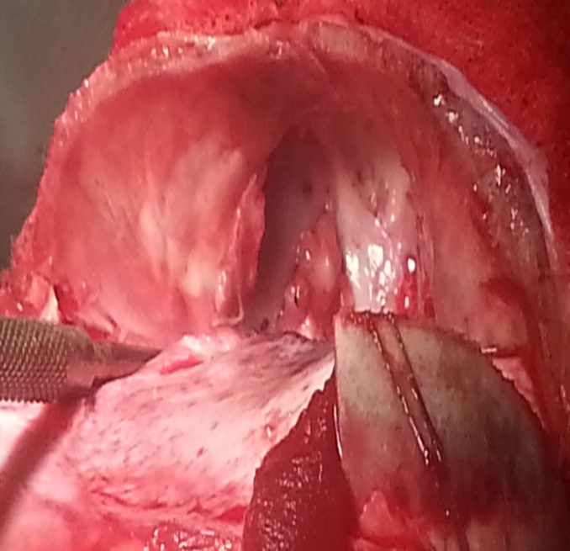 C 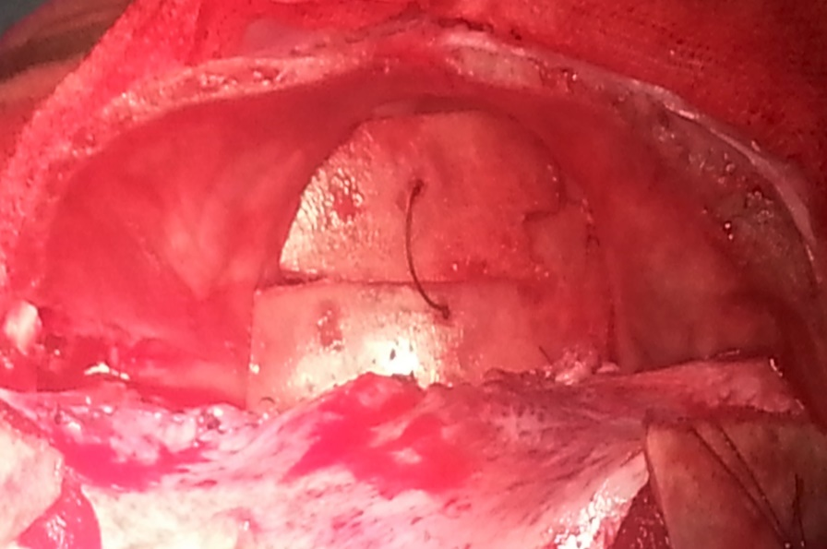

Figure 2: Types of encephaloceles; A) atretic, B) vault, C) occipital. D) occipito-cervical and E) double

A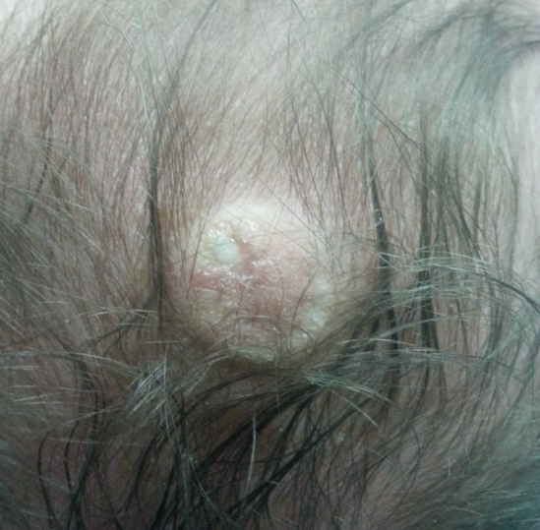 B 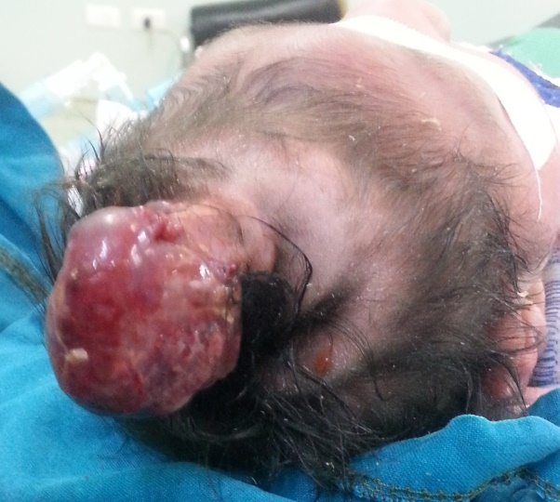
C 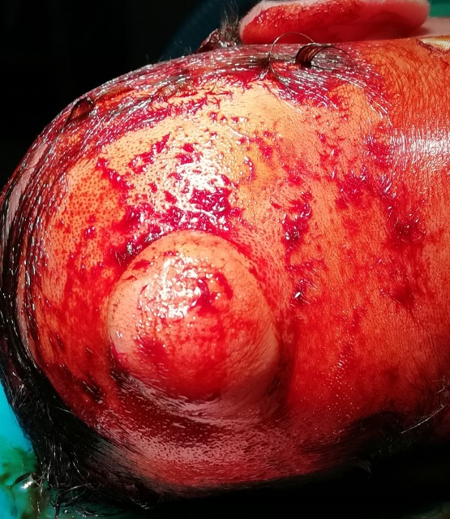 D 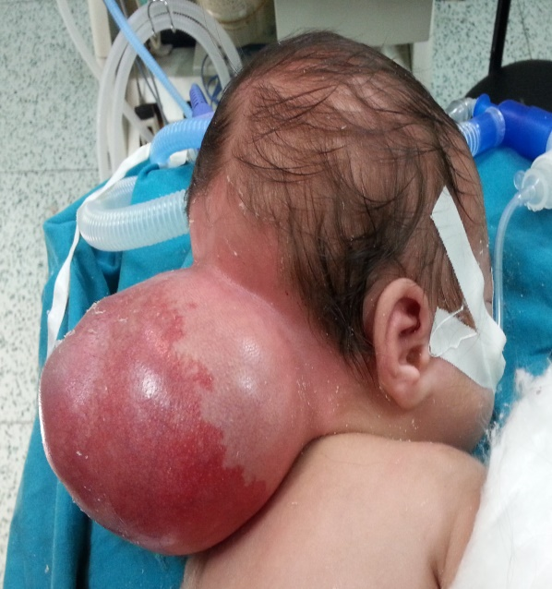
E 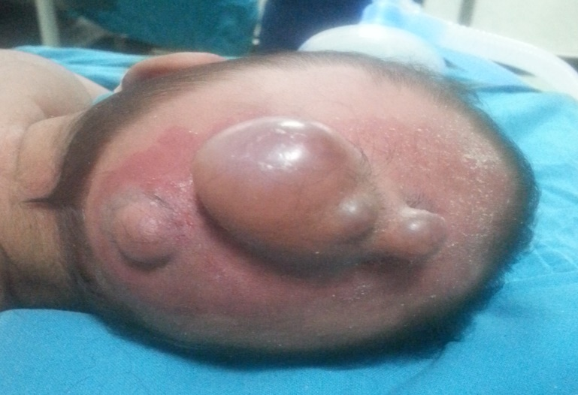

Figure 3: Large occipital encephalocele; A) lateral position, B) 3 months post-operative CT brain axial view with no hydrocephalus

A 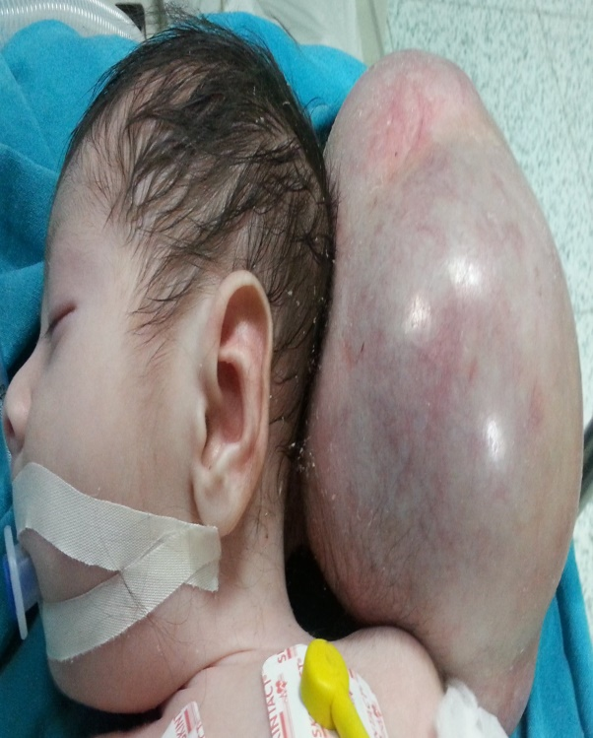 B 